**Performing Analysis Of Meteorological Data:**

*The H0means we need to find whether the average Apparent temperature for the month of a month say April starting from 2006 to 2016 and the average humidity for the same period have increased or not. This monthly analysis has to be done for all 12 months over the 10 year period. So you are basically resampling your data from hourly to monthly, then comparing the same month over the 10 year period.*

### **Step 1 :**

**Let's start by importing libraries :**

                        To make use of the functions in a module, you'll need to import the module with an import statement. An import statement is made up of the import keyword along with the name of the module.

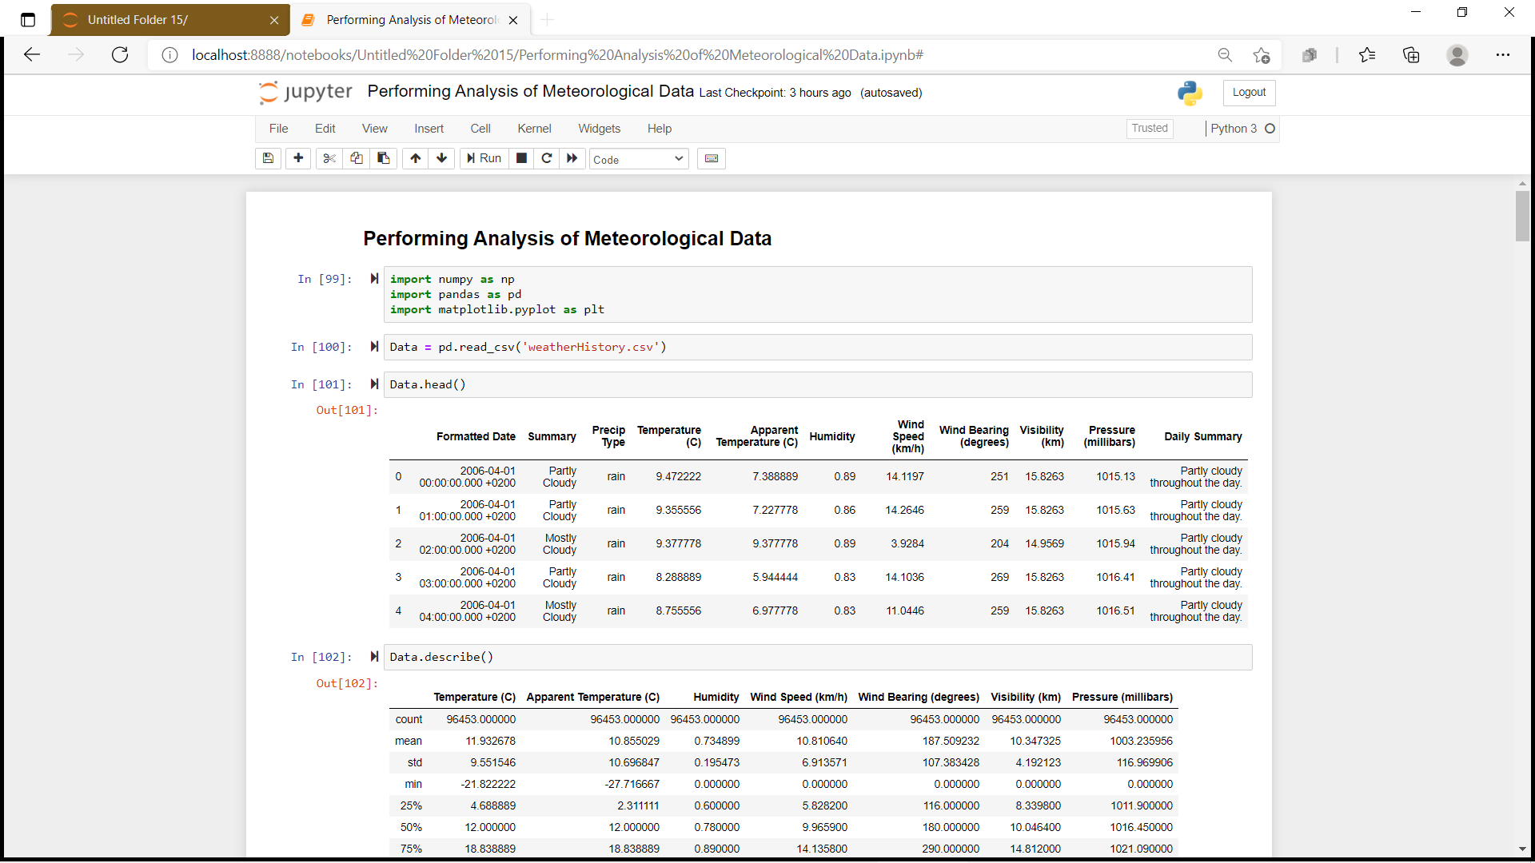

### **Step 2 :**

**Reading data-set using pandas library :**

                          A data-set is a collection of data. In the case of tabular data, a data set corresponds to one or more database tables, where every column of a table represents a particular variable, and each row corresponds to a given record of the data set in question. In this scenario we are going to read weather History data.

### **Step 3 :**

**Cleaning dataset :**

                           Data cleaning is the process of fixing or removing incorrect, corrupted, incorrectly formatted, duplicate, or incomplete data within a dataset . Dropping  unwanted data and converting it according to our requirement.

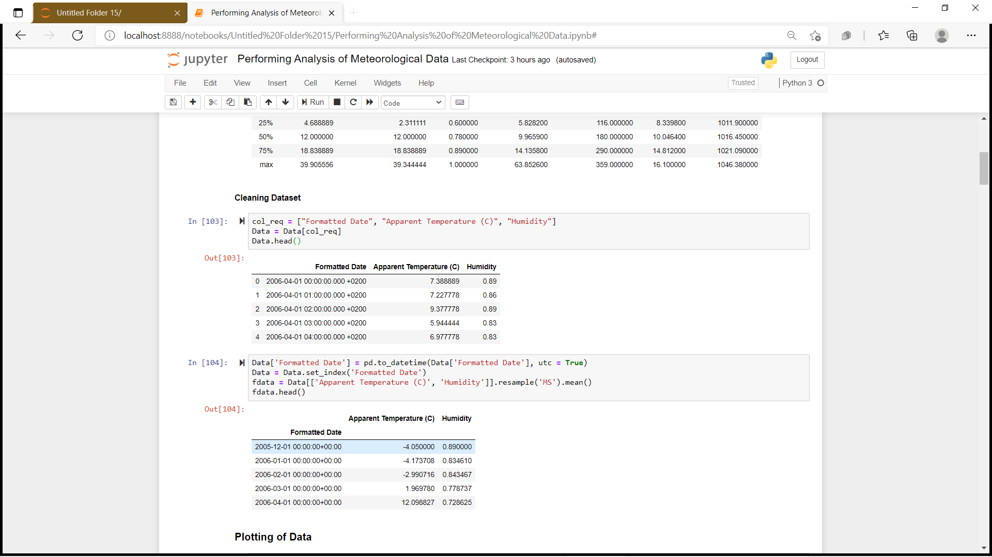

We need to analysis data yearly. We need to convert **Formatted Date**  into datetime format. We will do it by using pandas method **to_datetime()** . Also, we will set **Formatted** **Date** as the index to the data-set and resample our data .

### **Step 4 :**

**Plotting of Data :**

The purpose of plotting data is to visualize variation or show relationships between variables. We will now plot the line graph to display Average Humidity and Average Apparent Temperature over 10 years(2006–2016).

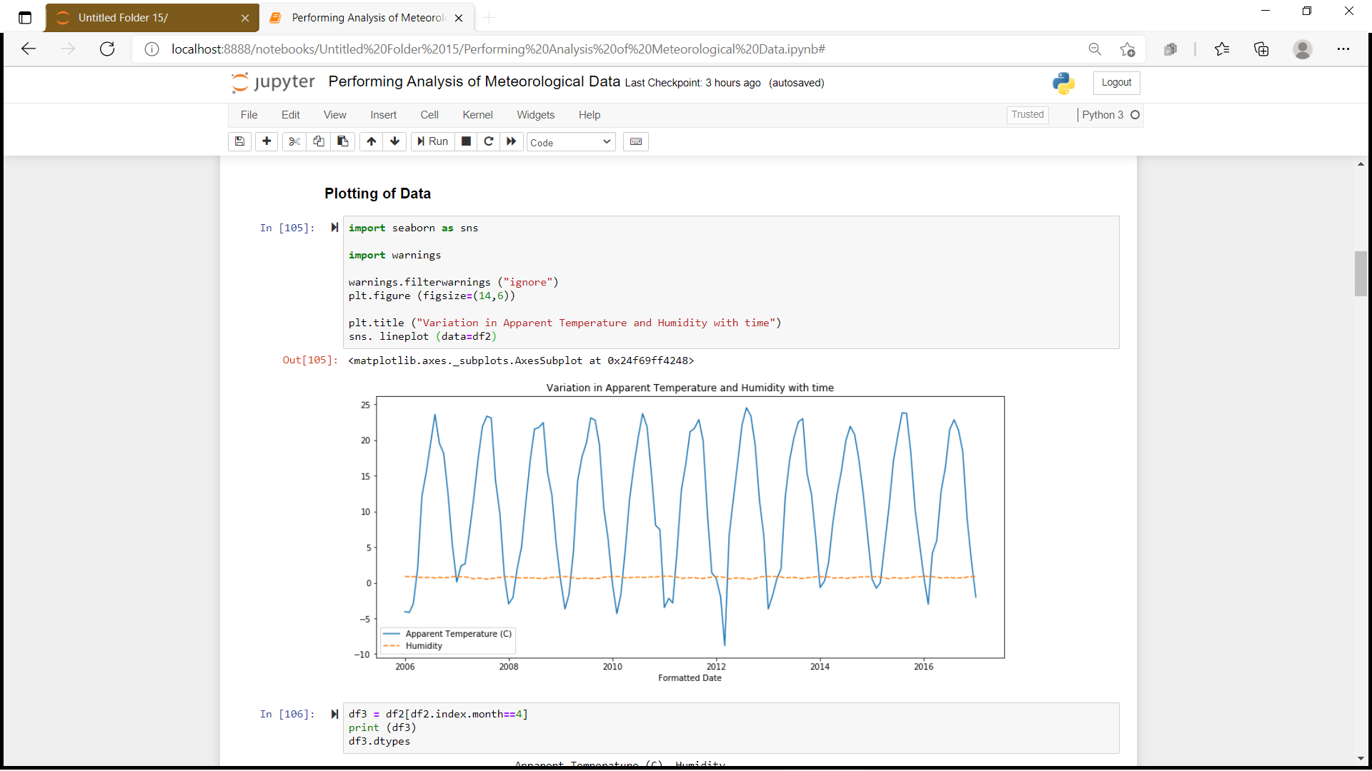

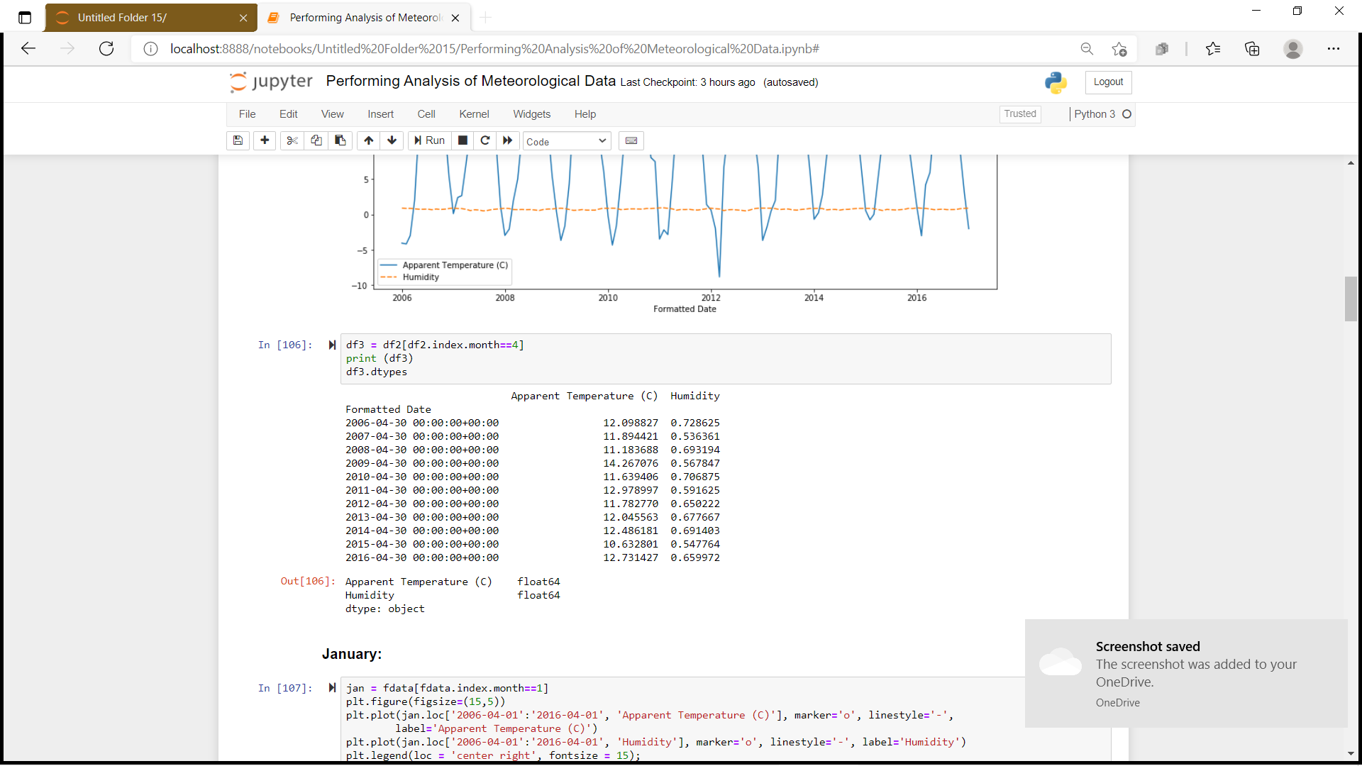

**\***We will now plot the line graph to display average temperature and humidity for  all 12 months over the 10 year period . Lets start from First month of the year.

1. January:

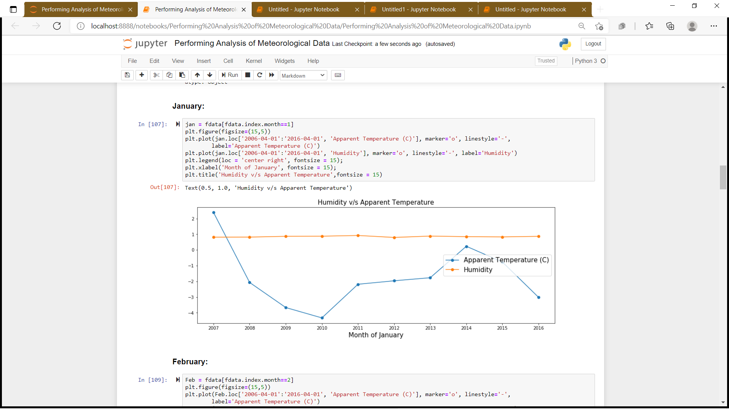

1. February:

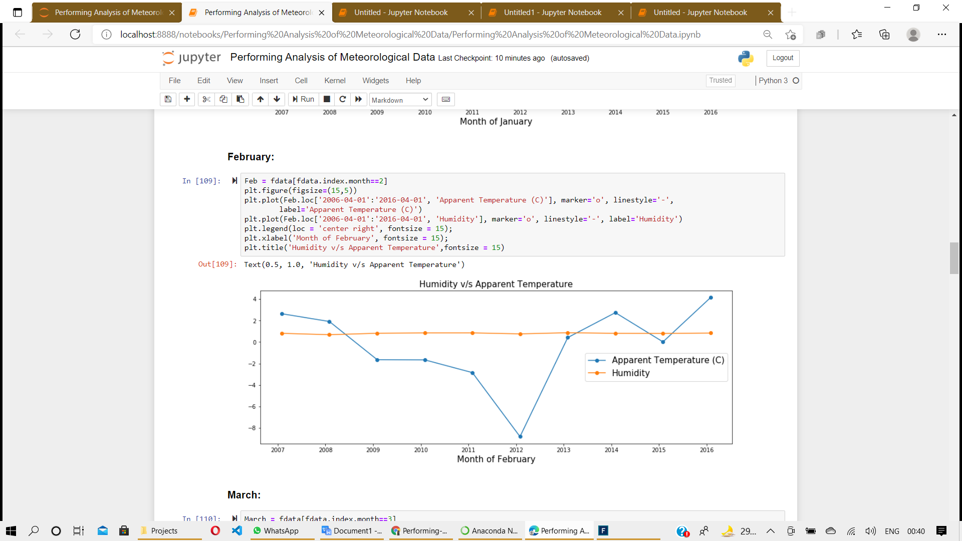

1. March:

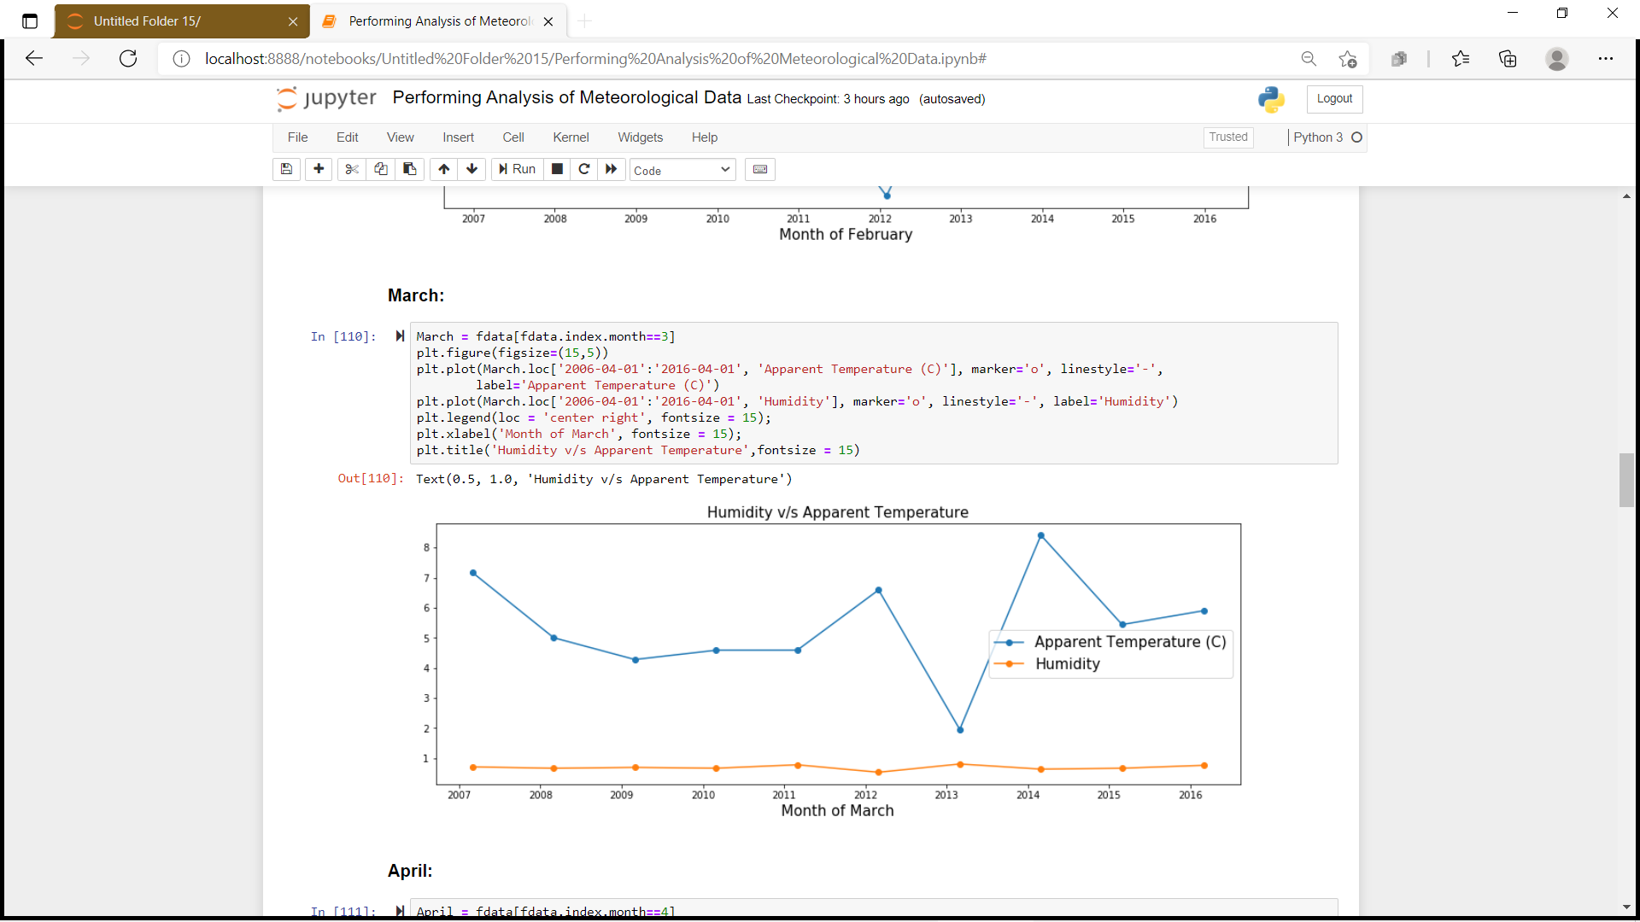

1. April:

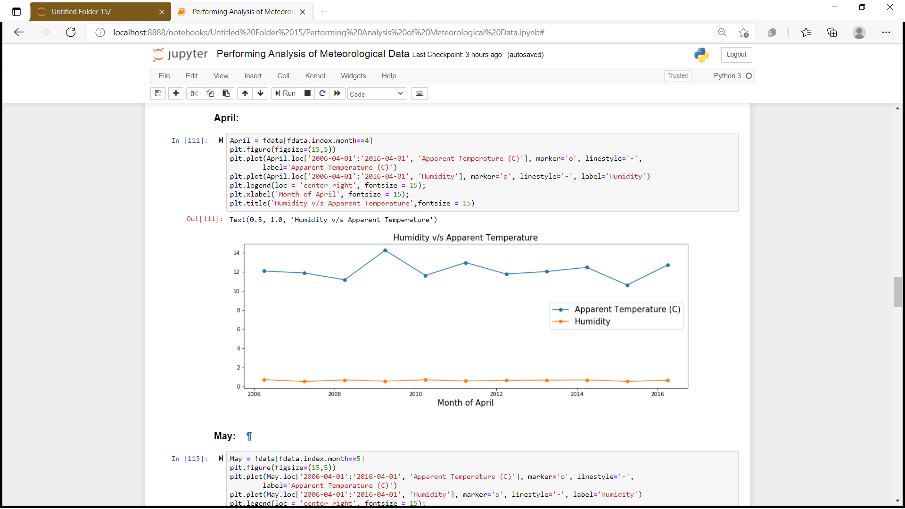

1. May:

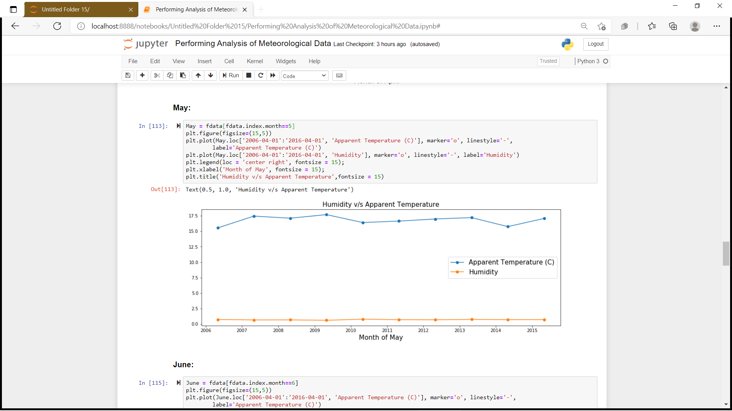

1. June:

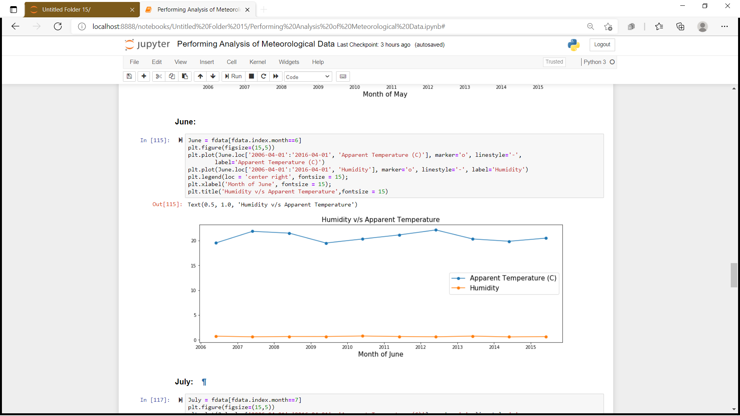

1. July:

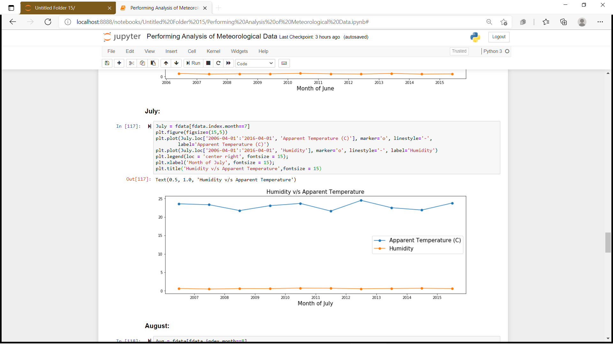

1. August:

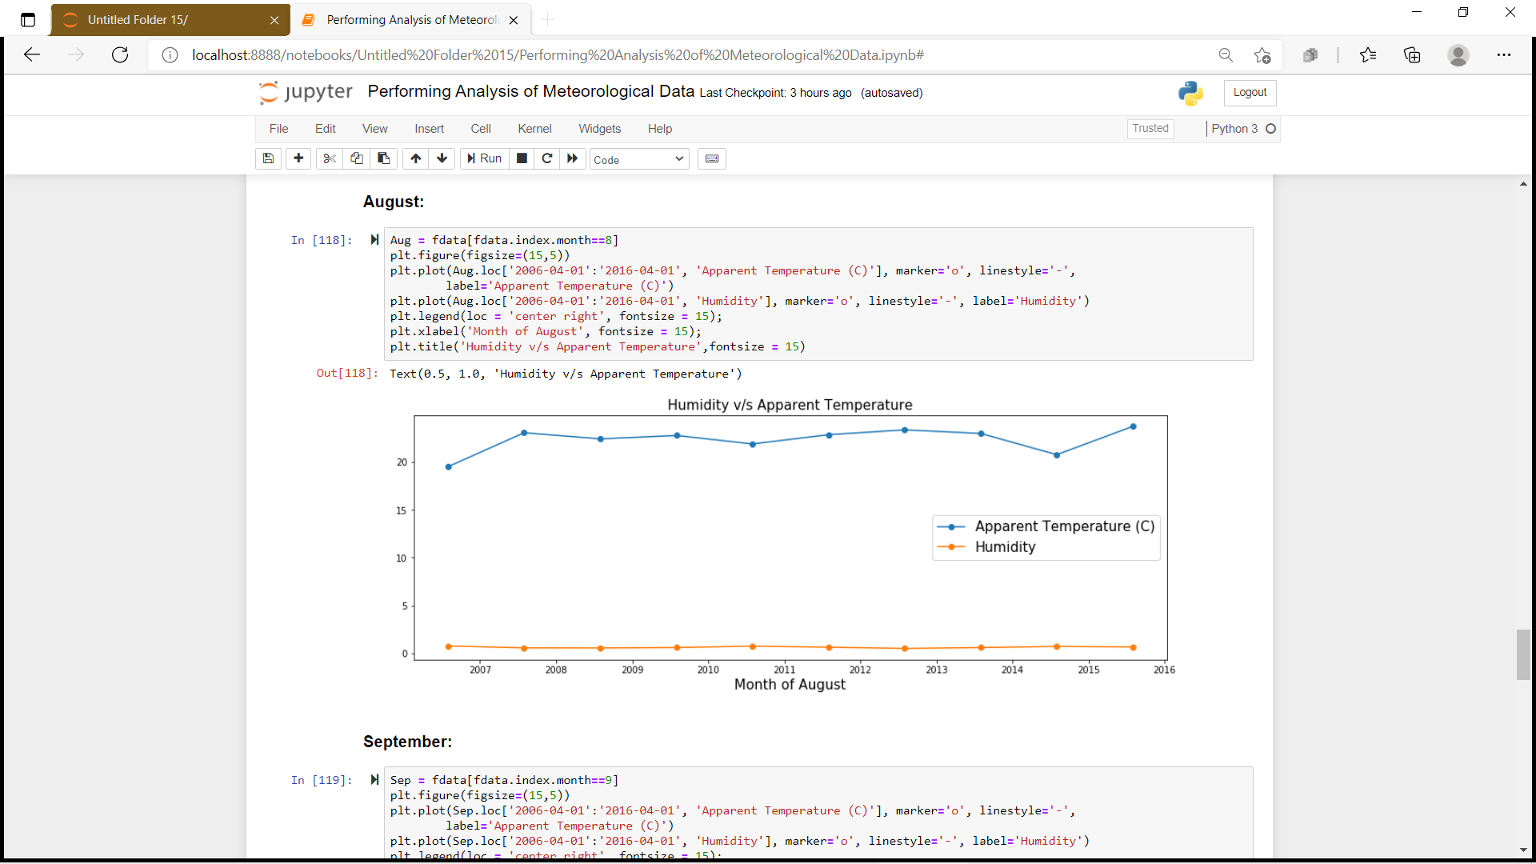

1. September:

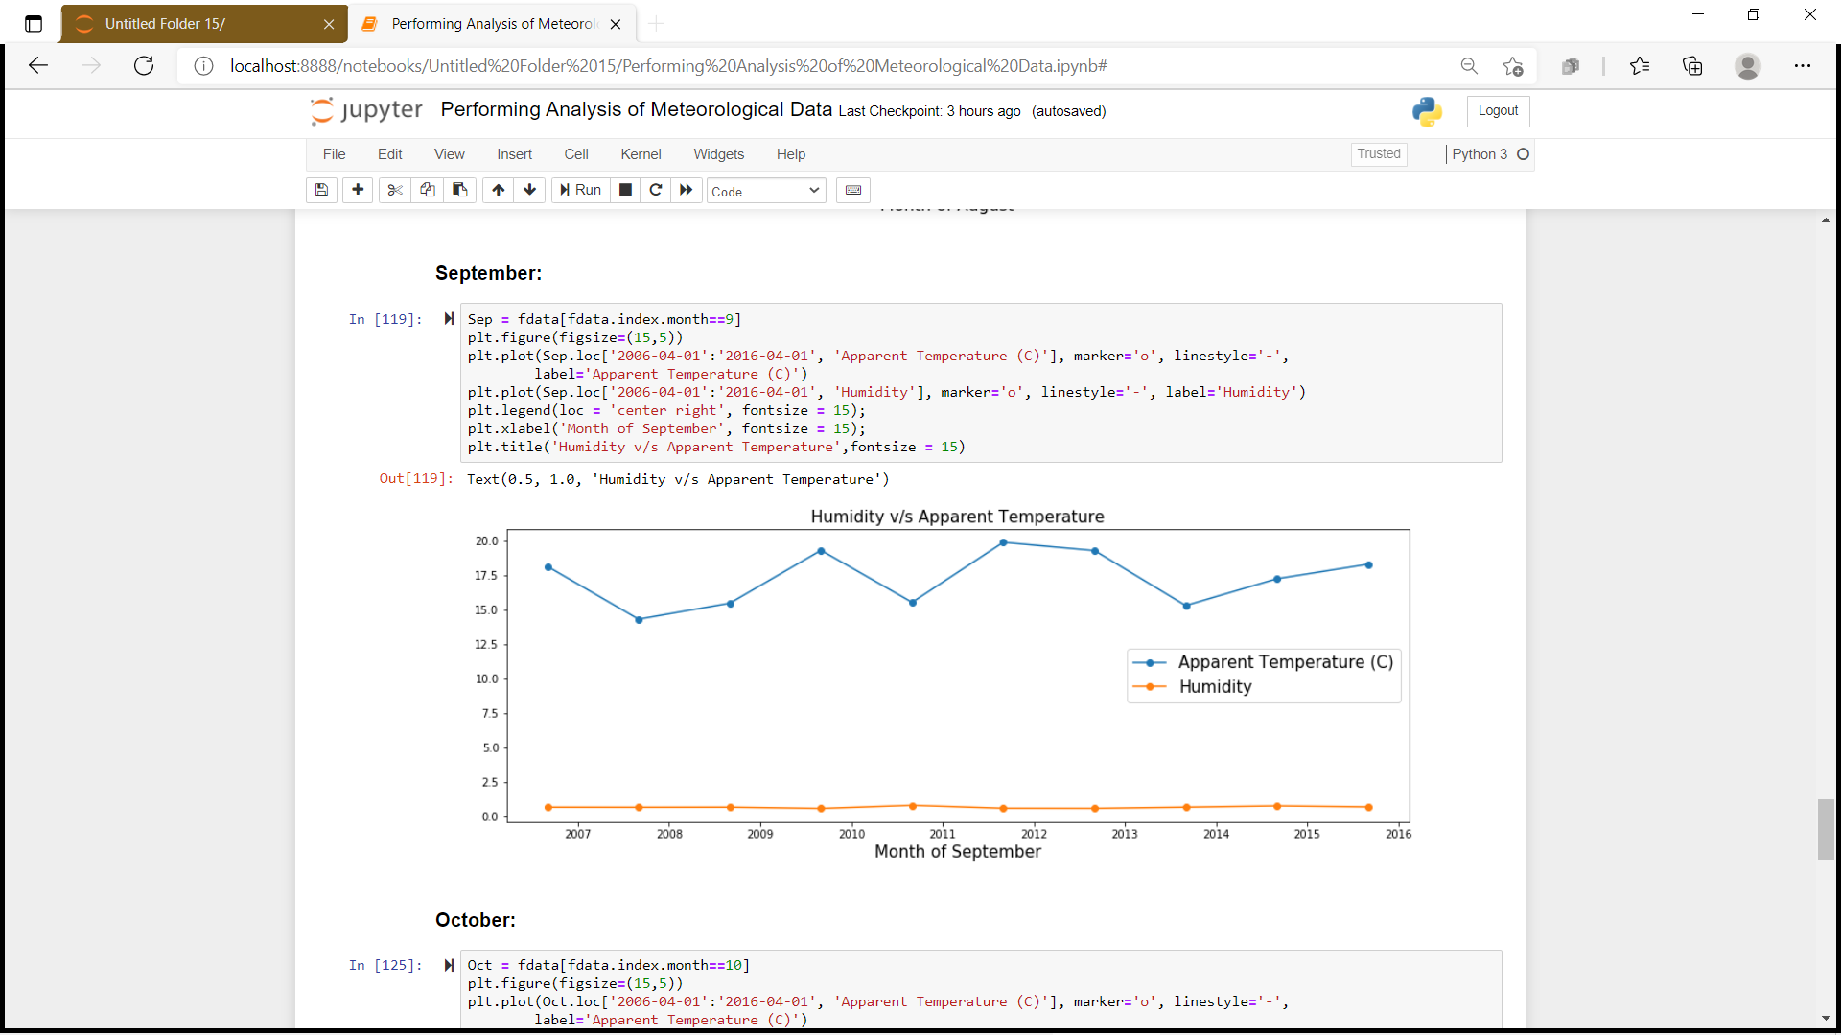

1. October:

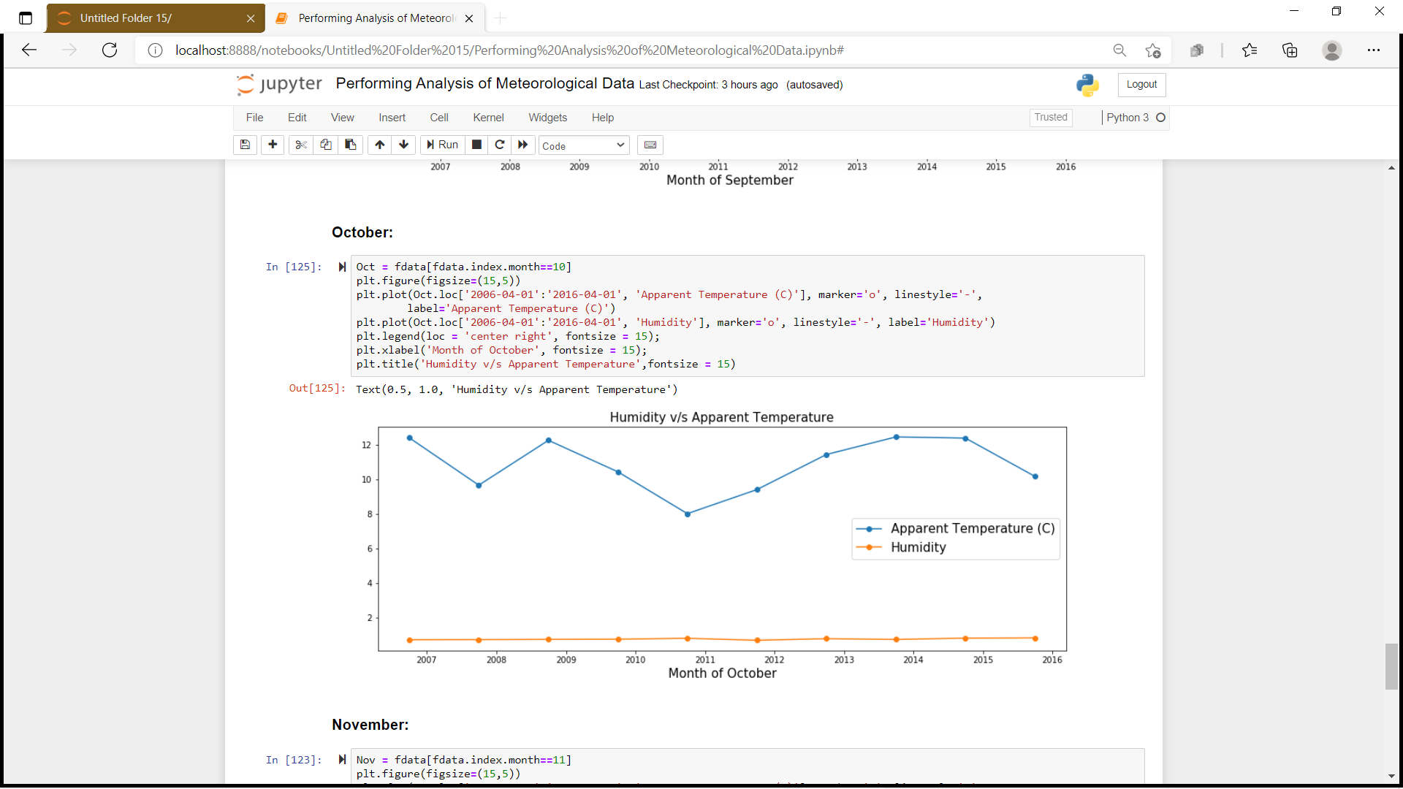

1. November:

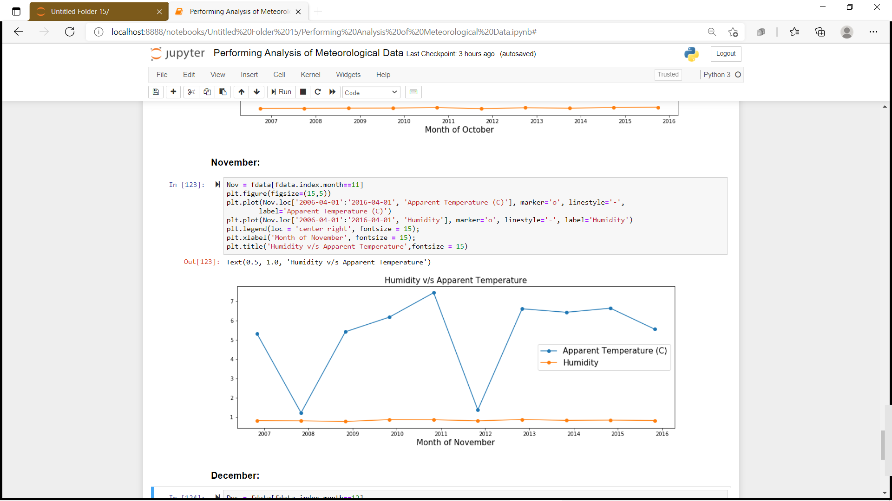

1. December:

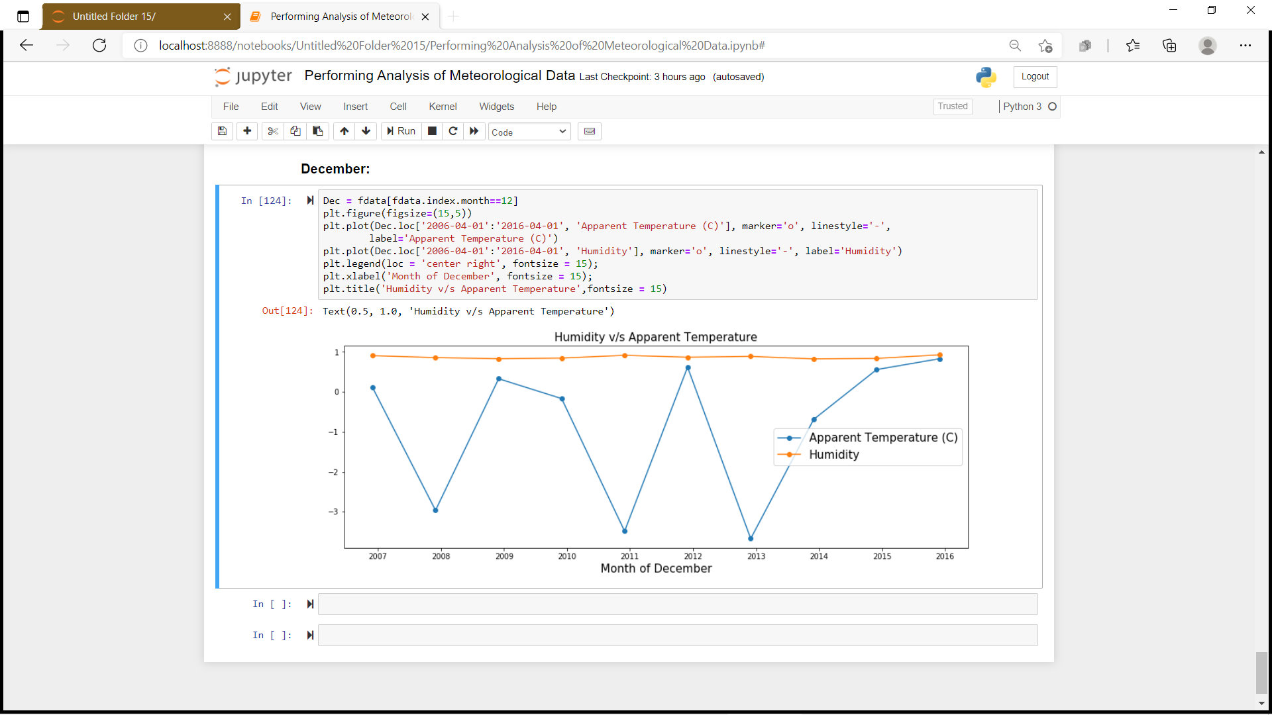

### **Conclusion :**

 As we can see in the above images  there are many ups and downs in the temperature. So , We can conclude that global warming has caused an uncertainty in the temperature over  past 10 years while the average humidity has remained constant throughout the 10 years.